**LAB 07**

**LAB EXERCISE:**

function triangle = myfunc(base,height)

triangle=1/2*base*height

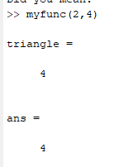

**EXERCISE 1:**

**USING BUILT IN FUNCTION:**

function sum = myfunc(x)

sum=sum(x)

function prod = myfunc(x)

p=prod(x)

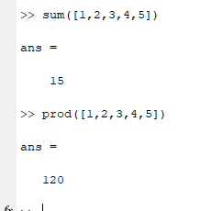

BY BUILTING NEW FUNCTIONS:

function result = myfunc(x)

sum=0

prod=1

for i=1:length(x)

sum=sum+x(1,i)

prod=prod*x(1,i)

end

disp(sum)

disp(prod)

end

 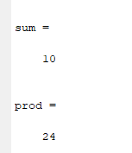

**EXERCISE 2:**

